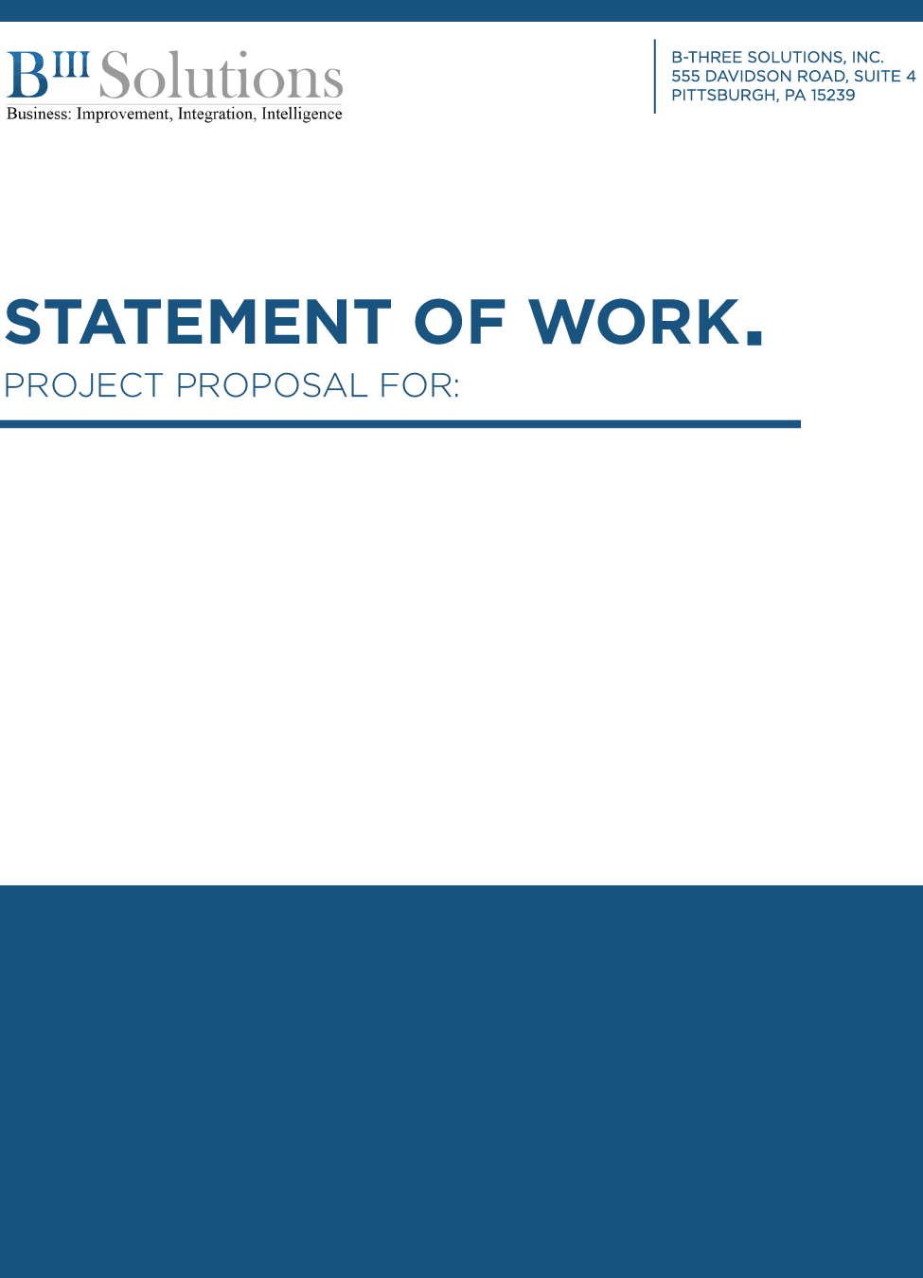

CLIENT:
City of Pittsburgh

DATE:
8/22/2024

PROJECT:
IMS Data Extract Phase II
City of Pittsburgh
IMS Data Extract Phase II

Client
City of Pittsburgh

Date
August 22, 2024

Description
This project extends the original IMS Data Extract SOW so that the data extraction process can be completed for the remaining document types. The original SOW was able to create and test the scripts for the data extraction but ran out of budget before the scripts were executed for all the legacy IMS Document Types.

The City of Pittsburgh CRRU (Records Room) is requesting, along with E-Docs, that the metadata extracted from the Police Imaging System be extended to include the data in the IMS system. The matching data and images will then be uploaded to the E-Docs OnBase system. This project solely covers the joining and extracting of data from Police Imaging and IMS systems into CSV files. The City and other vendors are responsible for importing the data into the new system.

Team
City of Pittsburgh Alexis Barone-Katze
B-Three Solutions: Bob Elliott

The metadata extracted from Police Imaging System is not sufficient for the City’s Records Room Unit (CRRU) to perform certain searches. As such, they would like this data to be combined with the data from the IMS system which is stored in an Oracle database. Once this project is completed, the IMS system and corresponding Oracle database can be retired from the City’s network.

This SOW is an extension of the original contract that started the data extract process so that the data can be exported for the remaining document types and uploaded to the eDocs SFTP site.

This project will execute the IMS data extract scripts against all remaining legacy IMS document types and export as much actor, location, and incident detail data as possible.

Once the program units are finished executing, the resulting data will again be exported into CSV files. These files and the corresponding images from the Police Imaging System will be uploaded to EDocs ShareBase for consumption.

Below are the Document Libraries whose data will be extracted.

RR - Bureau of Criminal Investigations | All eDocs
RR - Incident Supplementals | 2006 & Earlier
RR - Missing Persons | All eDocs
RR - Modus Operandi | All eDocs
RR - Offense 2.0 Reports | All eDocs
RR - Police Pursuit Reports | All eDocs
RR - Subject Resistance Reports | All eDocs
RR - Traffic Stop Reports | All eDocs
RR - Weapon Discharge Reports | All eDocs
RR - Hand Written non traffic Citations | All eDocs

B-Three will perform the work described above on a time-and-materials basis, at a rate of $125 USD/hour, with a not-to-exceed budget of $12,000 USD. On the first of the month and the sixteenth of the month, B-Three Solutions will send an invoice to the City of Pittsburgh covering the work performed since the preceding invoice. All invoices are due net 30 days. Due to the volume of data being collected and matched for each document type, and the unfamiliarity with the IMS database/schema, this estimate may require adjustment as the project progresses.

This Statement of Work is subject to the terms and conditions of “the Agreement” between B-Three and the City of Pittsburgh, dated 2/01/2024 (“the Agreement”). All Statements of Work on discrete software development projects are intended to be fully included with “the Agreement’s” Scope of Work and covered under the “Not to Exceed Budget” amount set forth in Paragraph 6 of “the Agreement.” This Statement of Work is automatically added as an Exhibit to “the Agreement” after review, approval, and execution by the City, which will include an accounting review by the Office of Management and Budget. In the event of any irreconcilable conflict between terms in this Statement of Work and “the Agreement,” “the Agreement” terms shall govern.

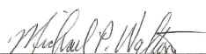 8/22/2024
Michael P. Walton Date
President
B-Three Solutions, Inc.

_____________________________________ ______________________________

PRINT NAME: _________________________ Date

TITLE:
Pittsburgh Bureau of Police, City of Pittsburgh

