To: The Honorable President and Members of Council
From: Rea Price, Acting Director
Date: July 16, 2026
Re: Acting Pay Request

Dear President and Members of Council:
This Communication is being forwarded to Council per the Acting Pay Policy, effective 6/3/2022.
The Office of Management and Budget is submitting an acting pay request on behalf of the Bureau of Fire for James Dolan on 6/22/26.
The acting pay request has been approved by the Mayor’s Office and the Office of Management & Budget.

Sincerely,
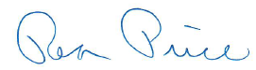
Rea Price
Acting Director

