June 8, 2026

The Honorable President and Members of Council
City County Building, 5th Floor
Pittsburgh, PA 15219

Dear President and Members of Council:

Attached is a proposed resolution authorizing the Mayor, the Director of the Office of Management and Budget, and the Director of the Department of Public Works to enter into an Agreement or Agreements with the Pennsylvania Department of Aging for the purpose of receiving grant funds in the amount not to exceed FORTY THOUSAND ($40,000.00) dollars to install flooring at the Homewood Healthy Active Living Center.

Your favorable consideration of this proposed Resolution is appreciated.

Sincerely,
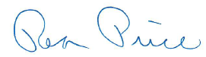

Rea Price
Acting Director

