May 26, 2026

The Honorable President and Members of Council
City County Building, 5th Floor
Pittsburgh, PA 15219

Dear President and Members of Council:

Attached is a proposed resolution authorizing, pursuant to Ch. 210 (“Acceptance of Gifts to City”) of the City Code, the Mayor and the Director of the Department of City Planning to accept a donation from Preservation Pittsburgh in the amount of TEN THOUSAND ($10,000.00) for the conservation of the Soldiers and Sailors Foundation in Arsenal Park.

Your favorable consideration of this proposed Resolution is appreciated.

Sincerely,

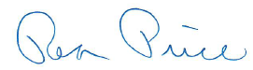

Rea Price
Deputy Director

