

EDWARD C. GAINEY CHRIS HORNSTEIN MAYOR DIRECTOR

CITY OF PITTSBUR GH

DEPARTMENT OF PUBLIC WORKS

CITY- COUN TY BUILDING

March 7, 2025

President and Members of City Council City Council

RE: Warrant-Canon Tools.

Dear President and Members of Council:
Attached is a proposed resolution Providing for the issuance of a warrant in favor of Canon Tools, in the amount of Thirteen Thousand Four Hundred & Ninety Nine Dollars and Ninety Eight cents ($13,499.98), for the Purchase of one Mac Scan tool, this tool is used for the repair of DPW vehicles; and providing for the payment of the costs thereof.
Funds are chargeable to and payable from the following operating account:
28003.4000280300.56.56401.2025
Your favorable consideration of the attached proposed resolution is hereby requested.

Sincerely,

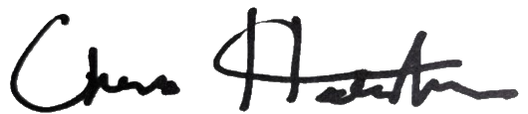
Chris Hornstein, RLA Department Director

CH/DM/JP

414 GRANT STREET | CITY-COUNTY BUILDING, THIRD FLOOR | 412-255-2586

