May 11, 2026

The Honorable President and Members of Council
City County Building, 5th Floor
Pittsburgh, PA 15219

Dear President and Members of Council:

Attached is a proposed Resolution amending resolution No. 680 of 2020, entitled “Resolution authorizing a Cooperation Agreement or Agreements with the Urban Redevelopment Authority of Pittsburgh in connection with the URA’s application for a Redevelopment Assistance Capital Program grant of up to $1,500,000 for the Former Homewood School project. (Council District 9)” to increase the total grant award, adjust the match, and assign an additional job number.

Your favorable consideration of this proposed Resolution is appreciated.

Sincerely,

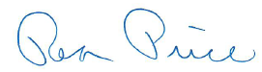

Rea Price
Acting Director

