
CITY OF PITTSBURGH
Office of Management and Budget
William Peduto, Mayor Kevin Pawlos, Director

July 30, 2026

The Honorable President and Members of Council
5th Floor, City-County Building
414 Grant Street
Pittsburgh, PA 15219

Dear President and Members of Council:

Attached is a resolution further amending Resolution No. 863 of 2018, effective January 1, 2019, as amended, entitled "Resolution adopting and approving the 2019 Capital Budget and the 2019 Community Development Block Grant Program, and the 2019 through 2024 Capital Improvement Program," so as to re-allocate Emergency Solutions Grant – Cares Act (ESG-CV) funding and authorize a subsequent Agreement or Agreements to provide emergency shelter services, street outreach services, rental assistance and housing relocation and stabilization services, and/or data collection activities.

Your favorable consideration of the Resolution is requested.

Sincerely,
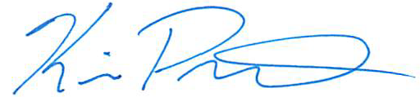

Kevin Pawlos
Director, Office of Management & Budget

Attachments

526 CITY-COUNTY BUILDING 414 GRANT STREET PITTSBURGH, PENNSYLVANIA 15219
www.pittsburghpa.gov

