APPLICATION: | DCP-MPZC-2023-01692
PROPERTY: | N Negley Avenue, Parcels 83-J-301, 83-J-300, 83-K-104, 83-K-102,  83-K-48, 83-K-60, and a portion of 83-K-61
PROPERTY OWNER: | MELLON'S ORCHARD ACQUISITION LLC; COSTELLO PROPERTIES LLC
NEIGHBORHOOD: | East Liberty
RCO: | Village Collaborative of East Liberty  Development Activities Meeting Date – June 11, 2024
ZONING DISTRICT: | RM-M (Multi-Unit Residential, Moderate Density); R2-M (Two-Unit Residential, Moderate Density)
PROPOSAL: | Rezoning to RM-VH (Multi-Unit Residential, Very High Density)
COUNCIL DISTRICT: | District 9; Councilman Khari Mosley
MEETING DATE: | July 23, 2024

FINDINGS OF FACT
- Master Plan/Zone Change Application DCP-MPZC-2023-01692 was filed by AE7, on behalf of the property owner, Mellon’s Orchard Acquisition, LLC, to change the zoning district on parcels 83-J-301, 83-J-300, 83-K-104, 83-K-102, 83-K-48, 83-K-60, and a
portion of 83-K-61 from RM-M (Multi-Unit Residential, Moderate Density) and R2-M (Two-Unit Residential, Moderate Density) to RM-VH (Multi-Unit Residential, Very High Density). A map of the proposed rezoning is attached to this report.
- The parcels involved in the proposed zone change are generally bound by N Negley Avenue, Rippey Street, and Rural Street in the East Liberty neighborhood.
- A portion of parcel 83-K-61 is included in the area proposed to be rezoned. This parcel is owned by Costello Properties, LLC. The applicant has submitted a Property Owner Authorization letter authorizing the applicant to submit the rezoning proposal for a portion of this parcel on behalf of Costello Properties, LLC.
- An application for the development of the above referenced parcels to allow for the construction of a 264-unit multi-unit residential building was denied by the Zoning Board of Adjustment (ZBA) and was subsequently appealed by Mellon’s Orchard Acquisition LLC. The applicant and the City of Pittsburgh entered into an agreement through Consent Order SA No. 23-000028 entered by Judge McGinley on September 25, 2023. Copies of the ZBA decision and the consent order are attached to this report.

- Enactment of this rezoning will permit multi-unit residential at a greater density than what is currently permitted. The proposed rezoning would also permit by-right multi- unit residential throughout the site, whereas multi-unit residential is not a permitted use in the portion of the site that is zoned R2-M.

- The applicant has provided renderings depicting the development bulk that would be permitted as a result of the rezoning in response to requests from the Planning Commission during the July 9th Briefing.

- Per Section 922.05.B.2, an application to amend the boundaries of the Zoning District Map may be proposed by the City Council, the Planning Commission, the owner of the subject property or the owner's agent.
- Per Section 922.05.D, the Planning Commission shall act to recommend approval or denial of the application within ninety (90) days of the receipt of the completed application. The application was deemed complete on May 10, 2024. The Hearing date of July 23, 2024 complies with the 90-day requirement.
- A Development Activities Meeting (DAM) was held with the Village Collaborative of East Liberty on June 11, 2024. A copy of the report is attached.
- Per code sections 922.01.C.1 and 922.01.C.2, property owners within 150 feet of the proposed zone change area were notified of the proposal and posted notice was placed on-site 21-days in advance of the July 23, 2024 hearing date.
- Under Section 922.05.F, the Planning Commission shall review the proposed Zoning Map Amendment according to certain criteria. Not all of the criteria must be given equal consideration by the Planning Commission in reaching a decision. The criteria to be considered shall be as follows:
  - The consistency of the proposal with adopted plans and policies of the City;
  - The convenience and welfare of the public;
  - The intent and purpose of this Zoning Code;
  - Compatibility of the proposal with the zoning, uses and character of the neighborhood;
  - The suitability of the subject property for the uses to which it has been restricted without the proposed zoning map amendment;
  - The extent to which approval of the proposed zoning map amendment will detrimentally affect nearby property;
  - The length of time the subject property has remained vacant as zoned;
  - Impact of the proposed development on community facilities and services; and
  - The recommendations of staff.

RECOMMENDED MOTION:

1. That the Planning Commission of the City of Pittsburgh APPROVES Master Plan/Zone Change Application, DCP-MPZC-2023-01692, based on the application filed by AE7, on behalf of the property owner, for a Zoning Map Amendment to change the zoning district on parcels 83-J-301, 83-J-300, 83- K-104, 83-K-102, 83-K-48, 83-K-60, and a portion of 83-K-61 from RM-M (Multi-Unit Residential, Moderate Density) and R2-M (Two-Unit Residential, Moderate Density) to RM-VH (Multi-Unit Residential, Very High Density) in the East Liberty neighborhood.

SUBMITTED BY:
Paul Cancilla, Principal Planner (Commissions and Code Development)
Zoning
Proposed Change

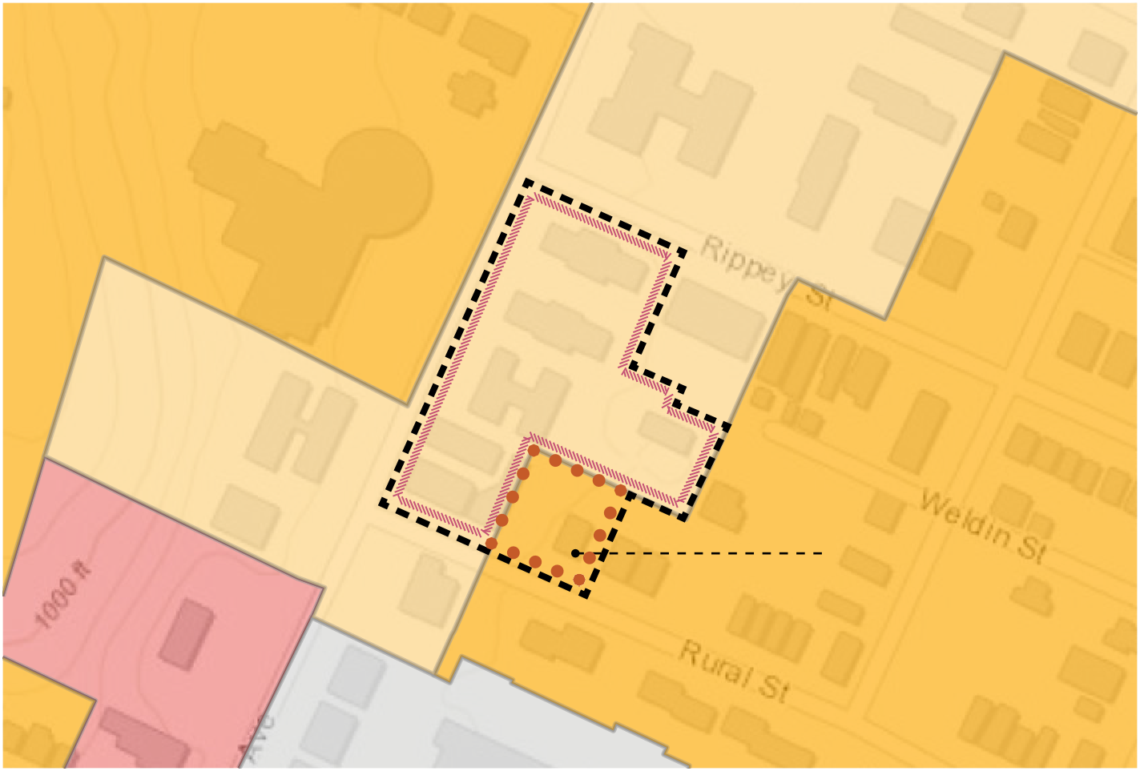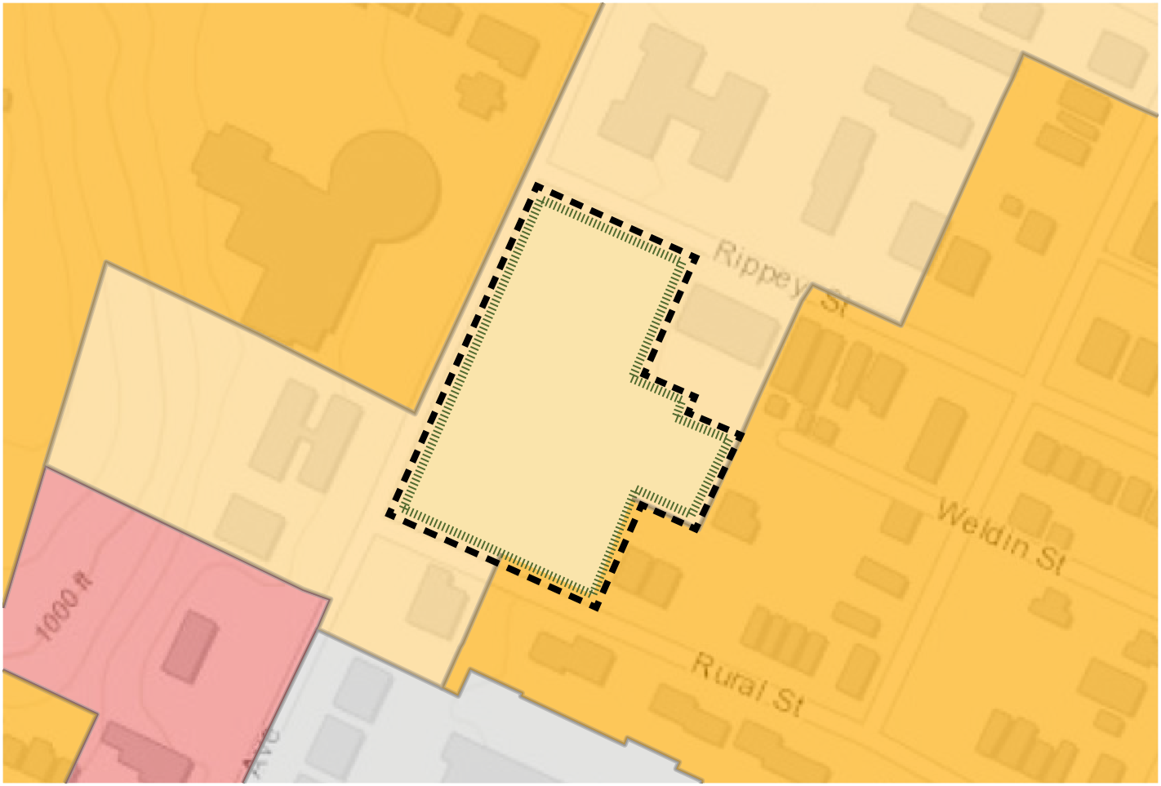
RM-M
SITE
R2-M
(3) current lots, zoned R-2
SITE
R2-M

Site
Portion of site currently zoned R2-M Portion of site currently zoned RM-M
Site
Portion of site proposed as RM-VH

Zoning Districts
 Planned Unit Development 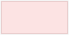 Local Neighborhood Commercial
 Urban Neighborhood Commercial
 Two-Unit Residential  Three-Unit Residential  Multi-Unit Residential  Zoning Districts Outlines




MELLON'S ORCHARD APARTMENTS REDEVELOPMENT SITE | ZONING CHANGE APPLICATION | JUNE 11, 2024 | 5


Division of Development Administration and Review
City of Pittsburgh, Department of City Planning
200 Ross Street, Third Floor Pittsburgh, Pennsylvania 15219
ZONING BOARD OF ADJUSTMENT
Date of Hearing: September 22, 2022 (Virtual Hearing)
Date of Decision: December 21, 2022
Zone Case: 190 of 2022
Address: 300 North Negley Avenue
Lot and Block: 83-J-300, 83-J-301, 83-K-102, 83-K-104, 83-K-6 83-K-48 and
83-K-60

Zoning Districts: RM-M, R2-M
Ward: 11
Neighborhood: East Liberty
Owner: Mellon’s Orchard Acquisition LLC
Applicant: Philip Wilkinson
Request: Construction of a 264-unit multi-unit residential building
Application: DCP-ZDR-2022-07755

Variances | Section 911.02  Section 903.03.C.2  Section 916.02.B.1  Section 916.02.B.2 | Multi-unit residential use prohibited in the R2-M District  1,800 sf minimum lot size per unit; 312 sf per unit requested  25’ minimum front setback; 9’ requested  25’ minimum rear setback; 1’ requested abutting Parcel No. 83-K-61  Maximum height permitted is 55’/4-stories; 70’-4”/6-stories requested  40’/3-stories maximum height within 50’ of R2 property; 57’-8”/5-stories requested  50’/4-stories maximum height within 51 to 100 feet of R2 property; 70’-4”/6-stories requested

The Zoning Board of Adjustment reserves the right to supplement the decision with Findings of Fact and Conclusions of Law.

Appearances:

Applicant: Robert Max Junker, Eric Jester, Craig Riegelnegg, Philip Wilkinson

Opposed: Harry Erlichman, Richard Gartner, Kristin Garbarino, Diana Haidar, Christopher Marks and Jonathan Cagwin
In-favor: Skip Schwab

Findings of Fact:
- Description of the Subject Property and Existing Conditions
  - The Applicant is Mellon’s Orchard Acquisition LLC (“Applicant”).

  - The Subject Property is located on North Negley Avenue in East Liberty and is comprised of 6 parcels, Parcel Nos. 83-J-300, 83-J-301, 83-K-102, 83-K-104, 83-K-48 and 83-K- 60, which the Applicant owns, and portions of a seventh parcel, Parcel No. 83-K-61, in which the Applicant has an equitable interest.
  - Parcel Nos. 83-J-301, 83-K-48 and 83-K-60 and portions of Parcel No. 83-K-61 are in an RM-M (Multi-Unit Residential, Moderate-Density) District and Parcel Nos. 83-J-300, 83-K- 102, and 83-K-104 are in an R2-M (Two-Unit Residential, Moderate-Density) District.
  - The combined area of the site is approximately 82,400 sf.

  - The grade of the property has a downward slope from the front property line on North Negley Avenue, with an elevation change of approximately 12 feet.
  - The combined site has frontages on North Negley Avenue, Rippey Street and Rural Street. The three street frontages and the shape of the combined site are consequences of the proposed consolidation of the various parcels.

  - At the rear, the site abuts parcels on Rippey Street, Weldin Street and Rural Street, in the R2-M District.

  - Weldin Street terminates at the rear of the site.

  - Located across North Negley Avenue from the Subject Property is a parcel within an R2-H (Two-Unit Residential, High Density) District, where the historic B’nai Israel synagogue structure is located. That structure includes an 80’ high rotunda feature and the Board approved a 62’/4-story addition to the rear of that property in Zone Case 273 of 2018.

  - The Subject Property is also proximate to the Negley/Penn Avenue LNC (Local Neighborhood Commercial) District and an RP (Residential Planned Unit Development) District on North Negley Avenue.

  - The uses in the area immediately surrounding the Subject Property include single- family houses and multi-unit residential buildings.

Existing Uses of the Subject Property
- Currently located on the various parcels that comprise the Subject Property are 6 three and four-story, multi-unit residential buildings, which contain a total of 78 units; a parking garage; and a surface parking lot.

- A 1971 Certificate of Occupancy for Parcel No. 83-J-301 (5611 Rural Street), permits a “3 story 9 family dwelling, with 3 lodgers” on that parcel.
- Certificates of Occupancy were not submitted with respect to the other existing buildings. However, the existing conditions of the site reflect previous use of the combined site for the three and four-story multi-unit residential structures.

- The surface parking lot is located on Parcel No. 83-J-300, within the R2-M District, and was used for parking for the residential on Parcel No. 83-J-301.

- The structures on the Subject Property are vacant and in a significant state of disrepair and their rehabilitation is not feasible.

Proposed Development of the Subject Property
- The Applicant proposes to demolish the existing structures and to redevelop the site for a single building with 264 residential units and a two-level underground parking garage.
- As proposed, the structure would have a C-shaped configuration with a central courtyard. The significant mass and maximum height of the structure would extend along North Negley Avenue, with a lower height at the rear of the site.
- The proposed structure would be set back 9’ from the front property line on North Negley Avenue; 25’ from the exterior side property line on Rippey Street; 25’ from the exterior side property line on Rural Street; and 1’ from the rear property line shared with Parcel No. 83-K- 61, at 5608 Rippey Street.
- The maximum height of the proposed structure would be 70’-4”/6-stories, along the front of the parcel on North Negley Avenue. The height would be reduced to 55’/5-stories towards the rear of the site, adjacent to the properties in the R2-M District.
- The distance between the 57’-8”/5-story portion of the structure and parcels in the R2-M District would be approximately 45’. The distance between the 70’-4”/6-story portion of the structure and parcels in the R2-M District would be less than 100’.
- The lot size per unit for the 264 units proposed for the 82,400 sf site would be 312 sf per unit.
- Consistent with the determination of the Department of City Planning that the proposed development would require 264 parking spaces and Code’s allowance of a reduction in the number of vehicle parking spaces where bicycle spaces are provided, the Applicant proposes
to provide 185 vehicle parking spaces and 80 bicycle parking spaces in the two-level underground parking garage.
- Of the 264 units proposed, the Applicant intends to provide 50 units that would be affordable to households that earn 50% of the area median income.

Evidence Presented in Support of the Requested Relief
- The Applicant provided a series of renderings that represent different views of the proposed development from Rippey Street, Rural Street and North Negley Avenue.
- The Applicant noted that the intent of the proposed 70’-4”/6-story height of the structure along the North Negley Avenue side of the site is to limit the impact of the structure’s mass and height on residential properties to the rear of the Subject Property.
- The Applicant noted that the height of the proposed structure would not exceed the 80’ height of the rotunda of the historic synagogue structure across North Negley Avenue.
- The Applicant identified several other multi-unit residential buildings in the proximate area of the Subject Property that have a similar lot size per unit and heights, as compared to the proposed building. However, in the list of properties used for comparison of density and height, the Applicant did not distinguish among buildings in the RM-M and R2-M Districts, where the Subject Property is located, and buildings located in nearby UNC (Urban Neighborhood Commercial), UI (Urban Industrial) and RM-VH (Residential Multi-Family Very High Density) Districts, which are subject to different density and height limitations. For the identified properties in RM-M and R2-M Districts, the Applicant did not indicate whether the density or height had been permitted by variance or whether they existed as legal nonconforming uses.
- The Applicant asserted that the site’s 12’ grade change is a unique characteristic that impacts how the site can be developed in compliance with the Code’s dimensional standards.
- The Applicant also offered testimony that Code’s 1,800 sf per unit density requirement is “suburban” in nature and is not consistent with the neighborhood.
- The Applicant presented an analysis of the economic feasibility of developing on the site the proposed multi-unit residential building, which incorporates 50 affordable housing units. The analysis concluded that the proposed density and height proposed are the minimum necessary to obtain financing for construction of that building, as proposed.
- The Applicant’s analysis addressed only the financial viability of the proposed development, assuming the inclusion of 50 “affordable” units and 214 market rate units. It does not consider other uses or structures that would be permitted in the RM-M and RM-2 Districts and does not identify how any of the asserted hardships associated with the site affect its economically viable use.
- The Applicant generally asserted that the use of the site for a multi-unit residential use would be consistent with the historic use of the various parcels that comprise the Subject Property.
- The Applicant also described the community process associated with the project and revisions to the initial design for the site that resulted from that process.
- The Village Collaborative of East Liberty, the Bloomfield Garfield Corporation, and East Liberty Development, Inc. submitted letters of support for the request.

Evidence Presented in Opposition to Proposed Relief
- Harry Erlichman, a resident of the property at 5647 Rural Street; Jonathan Cagwin, owner of the property at 5631 Rural Street; Christopher Marks, owner of the property at 600 North Negley Avenue; Diana Haidar, a resident of North Saint Clair Street; Kristin Garbarino, a resident of Rippey Street; and Richard Gartner, a resident of Rippey Street, all appeared at the hearing to oppose the request and to express concerns regarding the proposed height and density of the proposed development and its detrimental impacts on the surrounding area.

Post Hearing Submission
- The Applicant provided the Board with its post hearing submission on October 24, 2022 and the record closed as of that date. The Applicant agreed to an extension of time to this date for the issuance of the Board’s decision.

Conclusions of Law:
- Applicable Provisions of the Zoning Code
  - The site at issue here is located within two residential zoning districts: an RM-M District, where the multi-unit residential use is permitted; and an R2-M District, where that use is not permitted.
  - The site development standards for RM-M Districts are set forth in Section
903.03.C.2 and include 25’ minimum front, rear and exterior side and 10’ interior side setback requirements. The site development standards for RM-2 Districts, also in Section 903.03.C.2, include 30’ minimum front, rear and exterior side and 5’ interior side setback requirements.
  - Section 903.03.C.2 also provides that the minimum lot size per unit (density) requirement for all properties in Moderate Density Districts is 1,800 sf per unit.
  - Pursuant to Section 903.03.E.3, the minimum lot size per unit requirement in Very- High Density Districts, the highest density permitted in residential districts under the Code, is 400 sf per unit.
  - Chapter 916 of the Code sets forth the Residential Compatibility Standards. As stated in Section 916.01.A, the Residential Compatibility Standards “are intended to protect residential properties and neighborhoods from the adverse impacts sometimes associated with adjacent higher density and multi-unit residential development and non-residential development and uses.”
  - Section 916.02.B of the Residential Compatibility Standards imposes additional building height limitations where a proposed structure or “portions of a structure” would be
proximate to property in R1, R2, R3 or H Districts. Within 0’ to 50’ of property zoned R1, R2, R3 or H, the height of a structure or portions of a structure “shall not exceed forty (40) feet or three stories in height.” Within 51’ to 100’, structures or portions of structures “shall not exceed fifty
(50) feet or four stories in height.”
  - Section 916.09 allows the Board to waive Residential Compatibility Standards as a special exception, subject to certain standards. Section 916.09.C provides that the Residential Compatibility Standards for building height limitations may be waived “only if there is a taller intervening structure between the proposed structure and the adjacent residential district, in which case the height shall be limited to the height of the intervening structure.” Where, as here, no higher structure separates the proposed structure from a residential district, the Residential Compatibility Standards cannot be waived as a special exception and any relief from these height restrictions would require a variance.

Controlling Legal Principles
  - Section 922.09.E sets forth the general standards the Board is to consider with respect to variances. The criteria for determining whether to grant a variance include: 1) whether unique circumstances or conditions of a property would result in an unnecessary hardship; 2) whether the property could be developed in accordance with the Code’s requirements to allow for its reasonable use; 3) whether the applicant created the hardship; 4) whether the requested variance would adversely affect the essential character of the neighborhood or the public welfare; and 5) whether the variance requested is the minimum variance that would afford relief with the least modification possible. See Marshall v. City of Philadelphia and Zoning Bd. of Adj., 97 A.3d 323, 329 (Pa. 2014); Hertzberg v. Zoning Board of Adj. of the City of Pittsburgh, 721 A.2d 43 (Pa. 1998), citing Allegheny West Civic Council v. Zoning Bd. of Adj. of the City of Pittsburgh, 689 A.2d 225 (Pa. 1997); see also Metal Green Inc.
v. City of Philadelphia, 266 A.3d 495, 510 (Pa. 2021).
  - In discussing the “unnecessary hardship” standard, the courts have made clear that the applicant for a use variance is not required to demonstrate that a property would be “valueless” without a variance and that “multiple factors can be taken into account when assessing whether unnecessary hardship has been established.” Marshall, 97 A.3d at 330; see also Paganico v. Zoning Hearing Bd. of Penn Hills, 227 A.3d 949 (Pa. Commw. Ct. 2020), quoting Marshall. An unnecessary hardship can be established with evidence that: “(1) the physical features of the property are such that it cannot be used for a permitted purpose; or (2) the property can be conformed for a permitted use only at a prohibitive expense; or (3) the property has no value for any purpose permitted by the zoning ordinance.” Marshall, 97 A.3d at 329-30, quoting Hertzberg, 721 A.2d at 47 (citing Allegheny West Civic Council, Inc., 689 A.2d at 227-28).
  - An asserted “unnecessary hardship” must be unique to the property at issue and cannot arise from the impact of the zoning regulations on the entire district. Marshall, 97 A.3d at 329, citing Valley View Civic Association v. Zoning Bd. of Adj., 462 A.2d 637, 640 (Pa. 1983). Thus, the location of a property in a district where a use is not permitted does not, of itself, constitute a hardship under the established legal standards with respect to use variances.
  - Substantial evidence must support an assertion of an “unnecessary hardship.” In cases where courts have affirmed a zoning board’s grant of a use variance, the courts have noted the board’s finding of “unnecessary hardship” associated with the property, as based on
substantial evidence that the applicant has submitted. See, e.g., Marshall (century-old school building, which was vacant and in need of repair, limited development for permitted uses); Paganico (property had a triangular shape, with varying topography; was formerly used for a sewage treatment facility; had a 30’-wide sewer easement running through it; and was covered with poorly compacted fill materials); In re Appeal of Ridge Park Civic Ass’n, 240 A.3d 1029 (Pa. Commw. Ct. 2020) (long, narrow parcel with geotechnical and soils issues that would “impede and significantly increase the costs of development”); In re Garcia, 276 A.3d 340 (Pa. Commw. Ct. 2022) (lot with three street frontages, surrounded with commercial and industrial uses, which had remained vacant and blighted for decades).
  - Dimensional variances require only a reasonable adjustment of the zoning regulations to accommodate a use that is permitted in the relevant zoning district. Although a less restrictive application of the standards is appropriate when considering requests for dimensional variances, the applicant still bears the burden of presenting evidence that is intended to demonstrate that the proposed dimensional variance is warranted under the applicable standards. See Hertzberg, 721 A.2d at 47-48.
  - In One Meridian Partners v. Zoning Bd. of Adj. of Philadelphia, 867 A.2d 706, 710 (Pa. Commw. Ct. 2005), the Commonwealth Court considered a request for dimensional variances for a 615’/50-story high-rise condominium tower, which would have exceeded the permitted height by 94’. The Commonwealth Court reversed the zoning board’s grant of variances, noting the magnitude of the variances sought. It observed that, although Hertzberg eased the requirements for dimensional variances and allowed consideration of financial hardship resulting from dimensional restrictions, it did not eliminate the requirement of demonstrating a hardship associated with the property and that to hold otherwise would render dimensional requirements and local governments’ planning efforts meaningless. The court emphasized that a zoning code’s height limitations reflect a bona fide exercise of the city’s zoning power and that “the wisdom of such policy making is for City Council to decide.” 867 A.2d at 710. See also, O’Neill v. Zoning Bd. of Adj. of City of Philadelphia, 254 A.2d 12, 16 (1969) (where a building would contain over double the floor space typically allowed under zoning regulation, the appropriate remedy would be rezoning rather than a variance request).
  - Where no hardship is shown, or where the asserted hardship amounts simply to a desire to increase profitability, the “unnecessary hardship” standard required to obtain a variance is not satisfied, even under the relaxed Hertzberg standard for dimensional variances. Lamar Advantage GP Co. v. Zoning Hearing Bd. of Adj. of City of Pittsburgh, 997 A.2d 423, 445–46 (Pa. Commw. Ct. 2010); see also Lawrenceville Stakeholders v. City of Pittsburgh Zoning Bd. of Adjustment, 247 A.3d 465, 477 (Pa. Commw. Ct. 2021).
  - Where an applicant seeks either a use or dimensional variance, it is the applicant’s burden to present substantial and credible evidence in support of the request, in accordance with the applicable standards.
  - Code Section 923.02.B authorizes the Board to grant variances pursuant to the standards set forth in Section 922.09. However, the Board is not the City’s legislative body and cannot alter the Code’s requirements. See Hill v. Zoning Hearing Bd. of Maxatawny Twp., 597 A.2d 1245, 1258 (Pa. Commw. Ct. 1991) (only the governing body has the power to enact laws to regulate land use pursuant to its police power); see also One Meridian (establishing height limitations is policy-making and is for the governing body to decide).
  - Pennsylvania courts have long recognized that “a zoning board is not a legislative body, and it lacks authority to modify or amend the terms of a zoning ordinance.” Greth Development Group, Inc. v. Zoning Hearing Bd. of Lower Heidelberg Twp., 918 A.2d 181, 187 (Pa. Commw. Ct. 2007), citing Hill, 597 A.2d at 1251. As the court cautioned in Ludwig v. Zoning Hearing Bd. of Earl Twp., 658 A.2d 836, 838 (Pa. Commw. Ct. 1995), quoting Appeal of Kline, 148 A.2d 915, 916 (Pa. 1959), zoning boards “must not impose their concept of what the zoning ordinance should be, but rather their function is only to enforce the zoning ordinance in accordance with the applicable law.” See also Piscioneri v. Zoning Hearing Bd. of Borough of Munhall, 568 A.2d 610, 611 (Pa. 1990) (holding that zoning boards cannot substitute their concept of a good zoning ordinance for the one actually enacted).

The Density and Height Proposed Here Cannot Be Authorized through Variances and Legislative Action is Required to Alter the Applicable Code Provisions
  - The Code provides that, for Moderate Density residential districts, throughout the City, the appropriate lot minimum lot size per unit is 1,800 sf per unit. In Very-High Density districts, the lot size per unit requirement is 400 sf per unit.
  - The Applicant here seeks a variance to allow a 312 sf lot size per unit. In effect, the Applicant is asking the Board to create a new density standard, for this specific property, which would allow for a density higher than the Code’s highest, “Very-High Density,” standard.
  - The Code also provides that, in RM-M Districts, the height of structures is limited to 55’/4-stories, with additional height limitations designed to protect properties in lower density residential districts from the impacts of higher density and multi-unit residential development. Additional height limitations apply under the Residential Compatibility Standards because of the site’s proximity to parcels in the R2-M District. The Applicant seeks variances to allow for a structure with a maximum height of 70’-4”/6-stories, within 100’ of an R2-M District, as reduced to 57’-8”/5-stories within 50’ of the R2-M District.
  - The Board does not have the authority to alter the Code’s unambiguous density and height requirements to allow deviations of the order of magnitude proposed here, particularly where the Applicant did not present sufficient, substantial and credible evidence of unique conditions associated with the site that might justify the variances sought.
  - The financial hardship that the Applicant asserted related primarily to the cost of providing 50 affordable units, of the 264 units proposed, within the proposed development. That evidence did not demonstrate that the Subject Property could not be viably developed without variances, only that development of the Subject Property – for the proposed 264-unit residential structure – would not be economically viable without the requested variances, if the development includes what the Applicant defines as 50 affordable units.
  - The Board appreciates the Applicant’s efforts to address the lack of affordable housing in the City and its stated intent to provide 50 affordable units in the proposed development. The Board also appreciates the community process involved and the support for a development that would provide affordable units in the community.
  - However, any hardship associated with the need to provide affordable housing is not unique to the Subject Property but is a City, state and national challenge.
  - Widespread affordable housing challenges cannot be solved through ad hoc, property-by-property variance decisions of the Board. Solutions to challenges associated with providing affordable housing in the City are legislative in nature and a comprehensive, legislative approach is required.
  - The Board does not have the authority to impose its concept of what the zoning requirements should be when it considers individual applications that propose to include affordable housing. The Board cannot, through case-by-case decisions, select the properties where additional density and height should be allowed, beyond the limitations in the Code. The Board only has the authority to enforce what the governing body adopted in enacting the Code’s provisions. The Board is to grant variances only where the applicant presents substantial evidence of a unique hardship associated with the property that prevents strict compliance with the Code’s requirements and where the applicant demonstrates that the variance requested is the minimum that would afford relief.
  - If density requirements are to be altered, the governing body must determine the level of density to be allowed in the various zoning districts and must create new density standards, if it determines that new standards are appropriate. If properties are to be rezoned, the governing body must determine where new zoning district boundaries are to be drawn. If height limitations are to be altered to allow for greater density of development, the governing body must determine in what districts and under what conditions increased height should be permitted.
  - The Zoning Code also does not currently provide any guidance as to what constitutes an “affordable” residential unit. The Code does not authorize the Board to make that determination or to enforce a requirement of providing affordable units where an applicant expresses an intent to do so, based on a stated financing model for a proposed development.
  - Here, instead of attempting to develop a project within the constraints of the site and the Code’s requirements, the Applicant seems to have designed the project that it seeks to develop and to request variances that would allow for that specific project, regardless of the Code’s current development standards. Although the Applicant intends to include some affordable units in the development, the City’s need for affordable housing does not constitute a “hardship” that is unique to the Subject Property and does not allow the Board to essentially ignore the Code’s current density and height limitations or to create new standards.

Decision: The application for variances for the proposed development of the Subject Property is DENIED. The Board encourages the Applicant to seek the appropriate legislative remedies.

s/Alice B. Mitinger
Alice B. Mitinger, Chair

s/Lashawn Burton-Faulk RECUSED

LaShawn Burton-Faulk John J. Richardson
Note: Decision issued with electronic signatures, with the Board members’ review and approval.

IN THE COURT OF COMMON PLEAS OF ALLEGHENY COUNTY
PENNSYLVANIA

MELLON'S ORCHARD ACQUISITION ) C:vil Division LLC, )
) SA No. 23-000028
Appellant, )
) CONSENT ORDER OF COURT
v. )
) ZONING BOARD OF ADJUSTMENT OF ) THE CITY OF PITTSBURGH, )
)
Appellee, )
)
v. )
)
CITY OF PITTSBURGH, )
' )
Intervenor. )
IN THE COURT OF COMMON PLEAS OF ALLEGHENY COUNTY
PENNSYLVANIA

MELLON'S ORCHARD ACQUISITION LLC,

Appellant,
v.
ZONING BOARD OF ADJUSTMENT OF THE CITY OF PITTSBURGH,
Appellee,

v.
CITY OF PITTSBURGH,

Intervenor.
) Civil Division
)
) SA No. 23-000028
)
) CONSENT ORDER OF COURT
)
)
)
)
)
)
)
)
)
)
)
)

CONSENT ORDER OF COURT
AND NOW, this 2 f day of J2.ffz:h1 C
ORDERED, ADJUDGED and DECREED as follows:

, 2023, it is hereby

Recitals

- On January 19, 2023, Mellon's Orchard Acquisition LLC ("MOA'') filed a Notice of Zoning Appeal of the December 21, 2022 decision of the Zoning Board of Adjustment of the City of Pittsburgh (''ZBA") in Zone Case No. 190 of 2022, with which the ZBA denied MOA's application for variances to allow construction of a 264-unit residential building, with onsite parking, (the "Development") on property located on North Negley Avenue in East Liberty ("MOA's Property).

- MOA's Property is comprised of Allcghmy County Tax Parcel ID Nos. 83-J-301, 83-J-300, 83-K-104, 83-K-102, 83-K-48, and 83-K 0. Several of the parcels are located within an RM-M (Multi-Unit Residential, Moderare-Density) zoning district and several are within an R2-M (Two-Unit Residential, Moderate-Density) zoning district.
- MOA has a contractual agree:nent wrth m adjacent property owner to subdivide a
portion of property currently identified as Alleghen:; County Tax Parcel ID No. 83-K-6l, which is located within an RM-M (Multi-Unit Residential, Mo:lerate-Density) zoning district.
- The subdivided portion of Allegheny Cwnty Tax Parcel ID No. 83-K-6l is to be

consolidated with Allegheny County Tax Parcel No. 83-K-60.
- The parties have agreed to resolve thiJ m;3tter through this Consent Order of Court.

Terms Of The Parties' Agreement And This Consent Order

- The parties' agreement is expressly cor.tingent upon MOA receiving additional funding from third party entities for the 25% affordable: housing as required by the agreement.
- MOA will seek, from City Cwncil, the rfzoning of the entirety of MOA's Property (including the subdivided portion of Allegheny Coun-:y Tax Parcel ID No. 83-K-61) from the current RM-Mand RM-2 zoning designations to an RM-VH (Multi-Unit Residential, Very High Density) or a SP (Specially Planned) zoning distict designation, consistent with the ZBA's decision ("Proposed Rezoning").
- If City Council approves the Proposed F.ezoning, to the extent that any variances are required from any of the Zoning Code requirements for the Development, the City will support MOA in its application for any variances that were the subject of this action.
- The Parties agree that if (i) City Council approves the Proposed Rezoning, (ii) the ZBA approves any variances required from any of the Zoning Code's requirements for the Development, and (iii) MOA receives necessary funding from third-party entities then MOA will make 25% of the units in the Development affordabu: to tenants making 50% of the area median income (each an "affordable unit").
- This Consent Order shall be binding upon the parties and their successors and assigns.
- The parties agree that this Consent Onler is a settlement of a disputed claim and is based on MOA's Property, specifically, and shall not be construed as a precedent as to any future zoning application by MOA or any other party.
- Titis Court shall retain jurisdiction of this action for the purpose of facilitating additional settlement negotiations or rendering a decision on the merits of MOA's Notice of Zoning Appeal if the parties are unable to fulfil this agreement.

BY THE COURT:

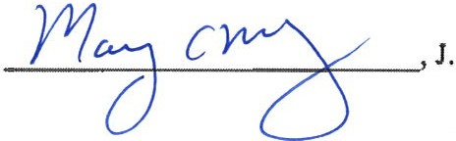

CONSENTED TO BY:

MELLON'S ORCHARD ACQUISITION ZONING BOARD OF ADJUSTMENT OF LLC THE CITY OF PITTSBURGH
.,,../;, . / _,.,.r"
/ J _..,,.,,,0/M ,._// ,,.,

By:
,/ _.,,,,-

,.
_
By:

Robert Max Junker, Esquire Alyssa E. Golfieri, Esquire
Babst Calland Clements & Zomnir, PC Two Gateway Center, 6th Floor
603 Stanwix Street
Pittsburgh, PA 15222 Attorneys for Mellon ·s Orchard Acquisition LLC
KryitiKubia1c, quire
City of Pittsburgh Law Department 313 City-County Building
414 Grant Street
Pittsburgh, PA 15219
Solicitor for the Zoning Board of Adjustment of the City of Pittsburgh

CITY OF PITTSBURGH

Byi . K: utb- City oPittsburgh Law Department 313 City-County Building
414 Grant Street
Pittsburgh, PA 15219
Solicitor for the City of Pittsburgh

Development Activities Meeting Report (Version: 06/24/2020)
This report created by the Neighborhood Planner and included with staff reports to City Boards and/or Commissions.

Logistics | Stakeholders
Project Name/Address: Mellon Orchard | Groups Represented (ex. specific organizations, residents, employees, etc. where this is evident): Village Collaborative of East Liberty, East Liberty Residents, East Liberty Business Owners, Department of City Planning
Parcel Number(s):
ZDR Application Number: DCP-MPZC-2023-01692
Meeting Location: Zoom
Date: 6/11/24
Meeting Start Time: 6:00 PM
Applicant: Philip Wilkinson | Approx. Number of Attendee: 58
How did the meeting inform the community about the development project?
Ex: Community engagement to-date, location and history of the site, demolition needs, building footprint and overall square footage, uses and activities (particularly on the ground floor), transportation needs, and parking proposed, building materials, design, and other aesthetic elements of the project, community uses, amenities and programs.

From the Applicant:

Mellon's Orchard is proposing the rezoning of 6 parcels, and a portion of a 7th parcel, located in East Liberty on or about N Negley Avenue between Rural Street and Rippey Street (Parcel ID Nos. 83-J-301, 83-J-300, 83-K-104, 83-K-102, 83-K-48, 83-K-60, and a portion of 83-K-61) from RM-M and RM-2 to RM-VH.

The rezoning of the above-referenced parcels was, among other things, addressed in a Consent Order entered by Judge McGinley on September 25, 2023, at 23-000028, and originated as a suggestion in one form or another from the Zoning Board of Adjustment, City's Zoning Administrator, Mayor's Office, and City Solicitor's Office as part of a global solution to a proposed multi-tenant residential development. A copy of the Consent Order has been uploaded for reference, as it provides a concise summary of the history of the proposed development.

This project includes a proposed 264- unit building. This project went before the Zoning Board of Adjustment in 2022 and was rejected. RM-M Multi-Unit Residential – Moderate Density zoning was used as a tool of prevention We will be utilizing 80/20 approach for this development.
Input and Responses
Questions and Comments from Attendees | Responses from Applicants
What is the required parking and how is that integrated into the project? | .7:1 ratio, reduced ratio due to bike parking. We edit not anticipate for as much parking need on site. We will have underground/structured parking that would meet the need of residents.
Affordability numbers and 1,000 is still unaffordable. As it relates to parking the parking does not seem adequate, they park on my street. Can you provide percentages? | Affordable units were 20 it is now 25 percent at 50 percent AMI. We will take Section 8 vouchers. or 66 units.
There are still houses on will street, are the develops interested in purchasing? | No, this is the extent of the project.
Parking .7:1 is that the current code or proposed code? | Current Zoning
What's the zoning of the synagogue across the street?
What are the next steps? | Planning Commission and City council
What's the math at 65 renovate v 200 new units | Its $200 ,000 per unit
Would the 66 affordable units be affordable in perpetuity? | 35 years and then evaluated at that time
I don’t think this reflects any changes since 2022. The current proposal does not I do not support spot zoning and it does not need to be changed to high density zoning. Parking is already an issue.
This needs to be brought down to a scale that fits the neighborhood.
Who votes at the meeting in July and who votes after? | We would go to Planning Commission in July, then City council. If approved, then variances from Zoning Board of Adjustment. Then they would have to go back to Planning Commission
I am a legacy resident. I have experienced the R-6 density zoning, and this zoning is similar. I do not think this is appropriate.
 | We do have a plan to have an indoor bus stop at our location. It is a public facility

I like what you are proposing
Concerns relative to parking, we are a one car family and with the reduction in bus routes
I am fully in support of this development. I wish there were more increase. There should not be spot zoning, but the zoning is so messed up we have to do it. What is the timetable? | Right after zoning approval.
Commend the project, the 25 percent affordable housing. Building in this area would be great to mitigate. Are you working with HACP? | We are working with the mayor’s office and every means possibles.
Is it possible for the buildings not to be so tall, and looking out on rural I would like to look out on something else. Parking is still a concern for me.
I love trees. I hope they will not grow so big that they will mess up the sidewalk | Be place them away back away from the street also in street Pittsburgh
Voice support for rezoning, plan and affordable housing. | Thanks.
We have lived on E. Fairmont for about 10 years now and we see it as the future and drive near amenities for us as well. Glad to see that this would have so much affordable housing | I appreciate your support
What are your resilience protections? | All electric building.
Going underground for parking, would it allow for that? | We have two levels.
The high density is too dense for this neighborhood We can not fix this with one block. It is not the low-income housing that is going to sell this issue. We need to have less density and commitment to low-income housing
I am happy to hear that there will be affordable units. But if the rezoning does not happen, they will not happen. ` | We have a consent decree. So, you do not have to take my word for it.
Do we need a traffic study?
What is return on investment period for this project? | Affodable housing is a straight loss. I’d have to figure that out, I’m unable to answer that right now.

I live in Garfield, and I support the project. There is a case for a broader reform. We need walkable communities and denser communities. I support communities and transformation.
Planner completing report: Ose Akinlotan, Planning Manager

