June 26, 2026

The Honorable President and Members of Council
5th Floor, Pittsburgh City-County Building
414 Grant Street
Pittsburgh, PA 15219

Dear President and Members of Council,

Please find attached for your consideration a resolution providing for a professional services agreement(s) and/or contract(s) with Malady & Wooten, Inc. for professional consulting services for state government affairs and legislative services and providing for the payment thereof at a cost not to exceed $264,000 over four years

Your favorable consideration is requested.

Sincerely,
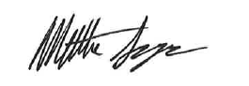

Matt Singer
Deputy Chief of Staff
Office of the Mayor

