July 7, 2026

The Honorable President and Members of Council
City County Building, 5th Floor
Pittsburgh, PA 15219

Dear President and Members of Council:

Attached is a proposed authorizing, pursuant to Ch. 210 (“Acceptance of Gifts to City”) of the City Code, the Mayor and the Director of the Department of Management and Budget to accept a donation from Carnegie Mellon University in the amount of THREE MILLION ($3,000,000.00) dollars split over the next five years for education and infrastructure initiatives.

Your favorable consideration of this proposed Resolution is appreciated.

Sincerely,

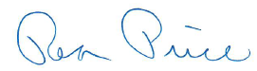

Rea Price
Deputy Director

