Fiscal Impact Statement
Updated 1/29/2020 to satisfy City Code §219.07

Department | Department of Public Works (DPW)
Preparer | Don Mudrick, Manager Personnel & Finance
Standing Committee Representative | Chris Hornstein, RLA, Director  Chris.hornstein@pittsburghpa.gov  (412)255-2783
Type of Legislation | Contract Authorization

Description of Legislation

We are further amending this contract with RouteSmart Technologies to both extend the usage one year to 2027 but also amend the delivery of the software which yields a savings to the taxpayer in the out years. In 2025 we are transitioning from an app-based platform to a web-based platform.

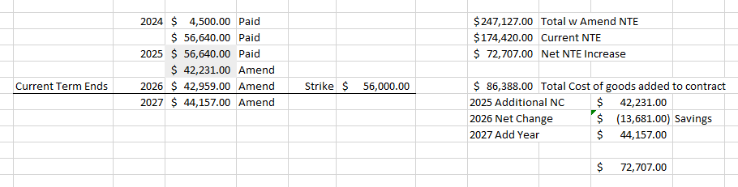
Total Cost | $271,127.00
Frequency of Expenditure | ☐ One-Time |  | ☒ Multi-Year
Funding Source | ☒ Operating | ☐ Capital | ☐ Grant | ☐ Trust Fund
Is this item budgeted? | ☒ Yes |  | ☐ No

JDE Account Information:
1030287500.53901.00 $4,500.00
For the one-time software and implementation component

And:
11101.430000.56.56151.2024 $56,640.00
11101.430000.56.56151.2025 $56,640.00
4000284300.56151.2025 $42,231.00
11101.430000.56.56151.2026 $42,959.00
11101.430000.56.56151.2027 $44,157.00
For recurring annual software maintenance

Additional Operational Costs
N/A

Impact on City Revenue
Expected renewals after term of current agreement.

