August 26, 2025

VIA EMAIL

President and Members of Council
City of Pittsburgh
City Council Chambers
520 City-County Building
Pittsburgh, Pennsylvania 15219-2464

Dear President and Members of Council:

This letter is to request approval for an Ordinance amending the City Code in order to add “housing status” as a protected class in the realm of housing discrimination. This would mean that if someone otherwise fulfilled the requirements to rent, it would be illegal to use someone’s stay in a shelter, on the streets or gaps in their rental history in order to deny them.

Your favorable consideration is appreciated.

Sincerely,
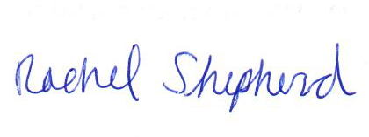
Rachel Shepherd
Director

Enclosures

