Fiscal Impact Statement
Updated 1/29/2020 to satisfy City Code §219.07

Department | Department of Public Works (DPW)
Preparer | Genesis Martinez, Executive Assistant
Standing Committee Representative | Chris Hornstein, RLA, Director  Chris.hornstein@pittsburghpa.gov  (412) 255-2783
Type of Legislation | Contract Authorization

Description of Legislation

We are merely amending Resolution 119 of 2025 to include also authorizing the Director of the Department of Innovation and Performance, who administers all City technological functions, to also enter into a Professional Services Agreement or Agreements with RouteSmart Technologies, Inc, along with the Director of the Department of Public Works, through November 30, 2027.

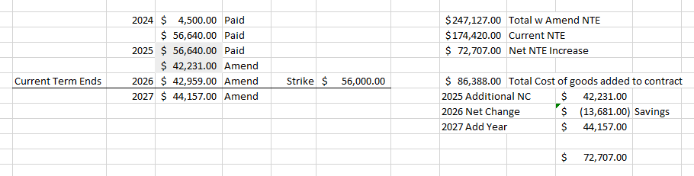
Total Cost | $271,127.00
Frequency of Expenditure | ☐ One-Time |  | ☒ Multi-Year
Funding Source | ☒ Operating | ☐ Capital | ☐ Grant | ☐ Trust Fund
Is this item budgeted? | ☒ Yes |  | ☐ No

JDE Account Information:
1030287500.53901.00 $4,500.00
For the one-time software and implementation component

And:
11101.430000.56.56151.2024 $56,640.00
11101.430000.56.56151.2025 $56,640.00
11101.430000.56.56151.2025 $42,231.00
11101.430000.56.56151.2026 $42,959.00
11101.430000.56.56151.2027 $44,157.00
For recurring annual software maintenance

Additional Operational Costs
N/A

Impact on City Revenue
Expected renewals after term of current agreement.
Method of Procurement  Select one. | ☐ RFP | ☐ Signed Waiver from OMB | ☒ Amendment to Existing Contract  Do not fill out the rest of the form.

Name of Vendor and Award Justification
List the name of the awarded vendor and its qualifications.

Other Respondents
List the other respondents. If there were none, clearly state that.

Selection Criteria
Describe the selection or scoring criteria.

Selection Committee Representation
List the department(s) or bureau(s) represented on the committee. Do not list individual names.

Waiver Justification
If a waiver was granted, explain the justification.

EORC Synopsis
Insert synopsis that was presented.

Date Presented at EORC: Insert date. | ☐ Approved | ☐ Not Approved

Per §219.07 of the City Code, you must include an electronic copy of the solicitation or your signed waiver with your submission to the Office of Management and Budget.

Attachments
- Please attach any additional documents and/or exhibits.

