July 29, 2026

Council President Lavelle and Members of Council
Fifth Floor
City County Building
Pittsburgh, PA 15219

Re: America 250 PA

Dear President and Members of Council,

The Department of Parks and Recreation will be submitting a resolution expressing the City of Pittsburgh’s support and endorsement of the Pennsylvania Commission for the United States semiquincentennial through its initiative: AMERICA250PA. By supporting this initiative, we can embrace AMERICA250PA's four pillars of EPIC, we hope to educate, preserve, innovate, and celebrate. This resolution will come at no cost to the City

Should you have any questions regarding the resolution or agreement, please do not hesitate to contact my office. Your favorable consideration is appreciated.

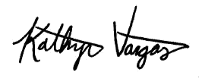
Very truly yours,
Kathryn Vargas
Director
KV/LH
Attachment

